# 

# PROJECT REPORT ON

# **OPINION OF VADODARA ON MAJOR CENTRAL GOVERNMENT DECISIONS**



# The Maharaja Sayajirao University of Baroda

# Department of Statistics

# Guided By:

# **Jayshree Madam**

# Presented By:

Aditya Sant

Mrinal Bankar

Mrunal Gokhale

Yuti Tailor

### CERTIFICATE

This is to certify that **Aditya Sant, Mrinal Bankar, Mrunal Gokhale and Yuti Tailor** have successfully and satisfactorily completed the project titled:

**“OPINION OF VADODARA ON MAJOR CENTRAL GOVERNMENT DECISIONS”**

as a team in the academic year 2019-20 and have submitted the work to the Department of Statistics in second semester as a partial fulfilment for the degree of Master of Science in Statistics and have represented their original work.

I wish them a grand success in future.

**Jayshree Madam Prof. V.A. Kalamkar**

## (Mentor)                                                                  Head of Department, Department of Statistics,

## Faculty of Science,

## Maharaja Sayajirao University of Baroda

ACKNOWLEDGEMENT

We have taken efforts in this project. However, it would not have been possible without the kind support and help of many individuals. We would like to extend my sincere thanks to all of them.

We are highly indebted to Mrs. Jayshree Shah for their guidance and constant supervision as well as for providing necessary information regarding the project & also for their support in completing the project.

We would like to express our gratitude towards our parents and the respondents who gave their precious time for their kind cooperation.

We would like to thank Prof. Vipul Kalamkar for their encouragement which helped us in completion of this project.

We would like to express our special gratitude and thanks to Prof. Amit Dholakia of the Department of Political Science for giving us such attention and time.

Our thanks and appreciations also go to our friends and  in developing the project and people who have willingly helped me out with their abilities.

Last but not the least we would like to thank our seniors for boosting our morale throughout the preparation of this project.

CONTENTS

**Chapter 1: Introduction**

* 1. Overview
  2. Objectives
  3. Method of Data collection
  4. Questionnaire
  5. Sample Size determination

**Chapter 2: Data Analysis**

* 1. Graphical Representation
  2. Primary Coded Data
  3. Chi-Square Test for Independence
  4. Multiple Response Analysis
  5. Proportion Test
  6. Conclusions
  7. Limitations
  8. References

Chapter 1: Introduction

* 1. **Overview**

**MAJOR CENTRAL GOVERNMENT DECISIONS**

1. Pradhan Mantri Awas Yojana - June 2015 (Scheme)
2. Demonetization - 8th November 2016 (Economic)
3. Surgical Strike (Uri) - 29th September 2016 (Security)
4. Goods and Services Tax (GST) - 1st July 2017 (Economic)
5. Air Strike (Pulwama) - 14th February 2019 (Security)
6. Motor Vehicles Amendment Law - 1st September 2019 (Security)

1. Pradhan Mantri Awas Yojana - June 2015 (Scheme)

It is an initiative by Government Of India in which affordable housing will be provided to the urban poor with a target of building 20 million affordable houses by 31st March 2022

2. Demonetization - 8th November 2016 (Economic)

The Government Of India announced the demonetization of all Rs. 500 and Rs. 1000 bank notes. It also announced the issuance of new Rs. 500 and Rs. 2000 bank notes in exchange for the demonetised bank notes.

3. Surgical Strike (Uri) - 29th September 2016 (Security)

The Indian Army lead a covert operation against a group of militants who attacked a base in Uri, Kashmir and killed many army soldiers.

4. Goods and Services Tax (GST) - 1st July 2017 (Economic)

GST is an indirect tax imposed in India on the supply of goods and services. It is a comprehensive, multistage, destination-based tax reform.

5. Air Strike (Pulwama) - 26th February 2019 (Security)

On 14th February 2019 a convoy of vehicles carrying security personnel on the Jammu Srinagar National Highway was attacked by a vehicle-borne suicide bomber at Lethpora (near Awantipora) in the Pulwama district, Jammu and Kashmir. The attack resulted in the deaths of 40 CRPF personnels and the attacker.

On 26th February 2019 as a revenge, Twelve Mirage 2000 fighter jets struck joint training camps of Jaish and LeT inside Pakistan and completely destroyed them by shelling 1,000 kg bombs. It took 19 minutes to complete the operation.

6. Motor Vehicles Amendment Law - 1st September 2019 (Security)

This Law increased fine for many traffic offences to check road accidents and improve the road safety in the country.

**1.2 Objectives**

Below are some of the objectives that we targeted during this study:

* To determine the effectiveness of central government decisions.
* To assess the relationship of the factors affecting the opinions.
* To assess whether the people’s opinions are influenced or independent

**1.3 Method of Data collection**

* We have divided Vadodara City into zones. Because of time constraints we randomly selected only 1 ward from each zone by simple random sampling without replacement.
* We have obtained our data through direct communication to respondents and our target population was citizens of Vadodara.
* But due to COVID lockdown, we tried to obtain further samples through google forms.As we have collected samples through google forms, we were unable to get the desired samples from each zones.

**1.4 Questionnaire**

**Survey location: VADODARA CITY**

**QUESTIONNAIRE**

1. **Age**

**[ ] 10-20 [ ] 20-30 [ ] 30-40 [ ] 40-50 [ ] 50-60 [ ] Above 60**

1. **Area of Residence: _____________________**
2. **Income (Monthly)**

**[ ] Below 10,000 [ ] 10k-25k [ ] 25k-50k [ ] 50k-1lakh [ ] 1 Lakh Above**

1. **Gender**

**[ ] Male [ ] Female [ ] Others**

1. **Occupation**

|  |  |  |
| --- | --- | --- |
| **SERVICE** | **SELF EMPLOYED** | **OTHERS** |
| **Private [ ]** | **Organized Sector [ ]** | **Homemaker [ ]** |
| **Government [ ]** | **Unorganized Sector [ ]** | **Student [ ]** |

1. **Education**

**[ ] 12th Pass [ ] Graduate [ ] Post Graduate [ ] Diploma [ ] PHD**

**(7) MOTOR VEHICLE ACT**

**(i) Do you know about this Decision ?**

**[ ] Yes [ ] No**

**(ii) Source of Opinion**

**[ ] Independent [ ] Friends [ ] Family [ ] Educational Institution [ ] Media**

**(iii) Source of Information**

|  |  |
| --- | --- |
| **MEDIA** | **SOCIAL MEDIA** |
| **Television [ ]** | **Facebook [ ]** |
| **Newspaper [ ]** | **WhatsApp [ ]** |
| **Radio [ ]** | **Instagram [ ]** |
|  | **Twitter [ ]** |

**(iv) Do you think it is helpful ?**

**[ ] Yes [ ] No**

**Why?**

|  |  |
| --- | --- |
| **YES** | **NO** |
| **Increase in Revenue [ ]** | **High Fine [ ]** |
| **Increase in safety of citizens [ ]** | **Helmet not easily available for every size [ ]** |
| **Decrease in Pollution [ ]** | **Bad behavior of traffic police [ ]** |
| **Decrease in crime because of new number plate [ ]** | **Corrupt Officers [ ]** |
| **E-Memo for fine payment [ ]** | **Inconvenience [ ]** |
|  | **High Insurance Fees [ ]** |

**(8) DEMONETISATION**

**(i) Do you know about this Decision ?**

**[ ] Yes [ ] No**

**(ii) Source of Opinion**

**[ ] Independent [ ] Friends [ ] Family [ ] Educational Institution [ ] Media**

**(iii) Source of Information**

|  |  |
| --- | --- |
| **MEDIA** | **SOCIAL MEDIA** |
| **Television [ ]** | **Facebook [ ]** |
| **Newspaper [ ]** | **WhatsApp [ ]** |
| **Radio [ ]** | **Instagram [ ]** |
|  | **Twitter [ ]** |

**(iv) Do you think it is helpful ?**

**[ ] Yes [ ] No**

**Why?**

|  |  |
| --- | --- |
| **YES** | **NO** |
| **Decrease in Fake Currency [ ]** | **Corrupt Officers [ ]** |
| **Decrease in Black Money [ ]** | **Inconvenience [ ]** |
| **New notes have good quality [ ]** | **Small/Medium size Industries were hit [ ]** |

**(9) AIR STRIKE (BALAKOT)**

**(i) Do you know about this Decision ?**

**[ ] Yes [ ] No**

**(ii) Source of Opinion**

**[ ] Independent [ ] Friends [ ] Family [ ] Educational Institution [ ] Media**

**(iii) Source of Information**

|  |  |
| --- | --- |
| **MEDIA** | **SOCIAL MEDIA** |
| **Television [ ]** | **Facebook [ ]** |
| **Newspaper [ ]** | **WhatsApp [ ]** |
| **Radio [ ]** | **Instagram [ ]** |
|  | **Twitter [ ]** |

**(10) SURGICAL STRIKE (URI)**

**(i) Do you know about this Decision ?**

**[ ] Yes [ ] No**

**(ii) Source of Opinion**

**[ ] Independent [ ] Friends [ ] Family [ ] Educational Institution [ ] Media**

**(iii) Source of Information**

|  |  |
| --- | --- |
| **MEDIA** | **SOCIAL MEDIA** |
| **Television [ ]** | **Facebook [ ]** |
| **Newspaper [ ]** | **WhatsApp [ ]** |
| **Radio [ ]** | **Instagram [ ]** |
|  | **Twitter [ ]** |

**(11) PRADHAN MANTRI AWAS YOGNA**

**(i) Do you know about this Decision ?**

**[ ] Yes [ ] No**

**(ii) Source of Opinion**

**[ ] Independent [ ] Friends [ ] Family [ ] Educational Institution [ ] Media**

**(iii) Source of Information**

|  |  |
| --- | --- |
| **MEDIA** | **SOCIAL MEDIA** |
| **Television [ ]** | **Facebook [ ]** |
| **Newspaper [ ]** | **WhatsApp [ ]** |
| **Radio [ ]** | **Instagram [ ]** |
|  | **Twitter [ ]** |

**(iv) Do you think it is helpful ?**

**[ ] Yes [ ] No**

**Why?**

|  |  |
| --- | --- |
| **YES** | **NO** |
| **Improvement in Lifestyle [ ]** | **Houses are far from city [ ]** |
| **Depends on Income [ ]** | **Lucky draw system [ ]** |
| **Great Amenities [ ]** | **Depends on Income [ ]** |

**For Non Retailers**

**(12) GOODS AND SERVICE TAX (GST)**

**(i) Do you know about this Decision ?**

**[ ] Yes [ ] No**

**(ii) Source of Information**

**[ ] Independent [ ] Friends [ ] Family [ ] Educational Institution [ ] Media**

**(iii) Source of Information**

|  |  |
| --- | --- |
| **MEDIA** | **SOCIAL MEDIA** |
| **Television [ ]** | **Facebook [ ]** |
| **Newspaper [ ]** | **WhatsApp [ ]** |
| **Radio [ ]** | **Instagram [ ]** |
|  | **Twitter [ ]** |

**(iv) Do you think it is helpful ?**

**[ ] Yes [ ] No**

**For Retailers Only**

**(i) Do you have GST No.?**

**[ ] Yes [ ] No**

**(ii) Do you think it is helpful ?**

**[ ] Yes [ ] No**

**Why?**

|  |  |
| --- | --- |
| **YES** | **NO** |
| **Positively affected my Business [ ]** | **Negatively affected my Business [ ]** |
| **Simplified and Unified tax system [ ]** | **GST system difficult to use [ ]** |
| **Need to pay every 2 months [ ]** | **Website not user friendly [ ]** |
| **Easy Registration [ ]** | **Servers gets overloaded often [ ]** |
| **Small businesses can decide their selling price [ ]** | **Need to pay every 2 months [ ]** |

**1.5 Sample Size determination**

**For Proportion Test**

Following table shows the proportion of the awareness of people for each decision.

|  |  |  |  |  |  |  |
| --- | --- | --- | --- | --- | --- | --- |
|  | **MVA** | **Demo** | **AS** | **SS** | **PMAY** | **GST** |
| **Yes** | 25 | 26 | 23 | 23 | 22 | 26 |
| **No** | 1 | 0 | 3 | 3 | 4 | 0 |

MVA = Motor Vehicle Act

Demo = Demonetization

AS = Air Strike

SS = Surgical Strike

PMAY = Pradhan Mantri Awas Yojana

GST = Goods and Service Tax

**Formula:**

|  |  |  |  |  |
| --- | --- | --- | --- | --- |
| |  | | --- | |  | |  |  |  |
|  |  |  |  |
| Where, |  |  |  |

N = Population Size =1670806

z = z-Score =1.95

p = proportion (per decision )

d = Margin of error = 0.05

|  |  |  |  |  |  |  |
| --- | --- | --- | --- | --- | --- | --- |
|  | **MVA** | **Demo** | **AS** | **SS** | **PMAY** | **GST** |
| **n** | 56.8244 | 0 | 156.826 | 156.826 | 200.0048 | 0 |

**Required Sample Size : 200.0048**

Due to covid-19 pandemic we were able to collect sample of size 107.

The margin of error allowed due to this is ,

|  |  |  |  |  |  |  |  |
| --- | --- | --- | --- | --- | --- | --- | --- |
|  | d   |  | | --- | |  | |  |  |  |  |  |
|  |  |  |  |  |  |  |
|  |  |  |  |  |  |  |
|  |  |  |  |  |  |  |

N = Population Size =1670806

z = z-Score =1.95

p = proportion (per decision )

n = 107

The following table represent the margin of error of each decision due to sample of size 107.

|  |  |  |  |  |  |  |
| --- | --- | --- | --- | --- | --- | --- |
|  | **MVA** | **Demo.** | **AS** | **SS** | **PMAY** | **GST** |
| d | 0.03644 | 0 | 0.060533 | 0.060533 | 0.068361316 | 0 |

**Max Margin of Error $≈$ 7%**

**For Chi Square test of independence**

We are going to use chi square test of independence to asses the relationship between factor effecting opinions. So we will now determine the sample size for Chi Square test of independence.

This is done by following package of python.

GofChisquarePower.solve_power

(*effect_size=None*, *nobs=None*, *alpha=None*, *power=None*, *n_bins=2*)

solve for any one parameter of the power of a one sample chisquare-test

for the one sample chisquare-test the keywords are:

effect_size, nobs, alpha, power

Exactly one needs to be None, all others need numeric values.

n_bins needs to be defined, a default=2 is used.

Parameters

effect_size [float](https://docs.python.org/3/library/functions.html#float)

here we have taken the value of Cramer’s V from Chisquare contingency table.

nobs [int](https://docs.python.org/3/library/functions.html#int) or [float](https://docs.python.org/3/library/functions.html#float)

sample size, number of observations.

alpha [float](https://docs.python.org/3/library/functions.html#float) in interval (0,1).

significance level, e.g. 0.05, is the probability of a type I error, that is wrong rejections if the Null Hypothesis is true.

power [float](https://docs.python.org/3/library/functions.html#float) in interval (0,1)

power of the test, e.g. 0.8, is one minus the probability of a type II error. Power is the probability that the test correctly rejects the Null Hypothesis if the Alternative Hypothesis is true.

n_bins [int](https://docs.python.org/3/library/functions.html#int)

number of bins or cells in the distribution

First we found the sample size for Motor Vehicle Act - considering (Age, Gender,Occupation,Education,Income) v/s (Awareness,Helpfulness) - using **chipower.solve_power** function in statsmodels module. Similarly we did it for all the other decisions.

**Motor Vehicle Act**

chipower=power.GofChisquarePower()

import statsmodels.stats.power as power

A=chipower.solve_power(0.216,nobs=None,alpha=0.05,power=0.8,n_bins=4)

print("Gender*Awareness:-",A)

**#Output**

Gender*Awareness:- 233.6797682402473

The following table represents the maximum sample sizes determined for each decision :

|  |  |  |  |  |  |  |
| --- | --- | --- | --- | --- | --- | --- |
|  | **MVA** | **Demo** | **AS** | **SS** | **PMAY** | **GST** |
| **n** | 310.37 | 229.82 | 491.084 | 491.084 | 184.56 | 366.95 |

MVA = Motor Vehicle Act

Demo = Demonetization

AS = Air Strike

SS = Surgical Strike

PMAY = Pradhan Mantri Awas Yojana

GST = Goods and Service Tax

n = Max Sample Size (of association test per Decision )

**Required Sample Size : 491**

Chapter 2: Data Analysis

**2.1 Graphical Representation**

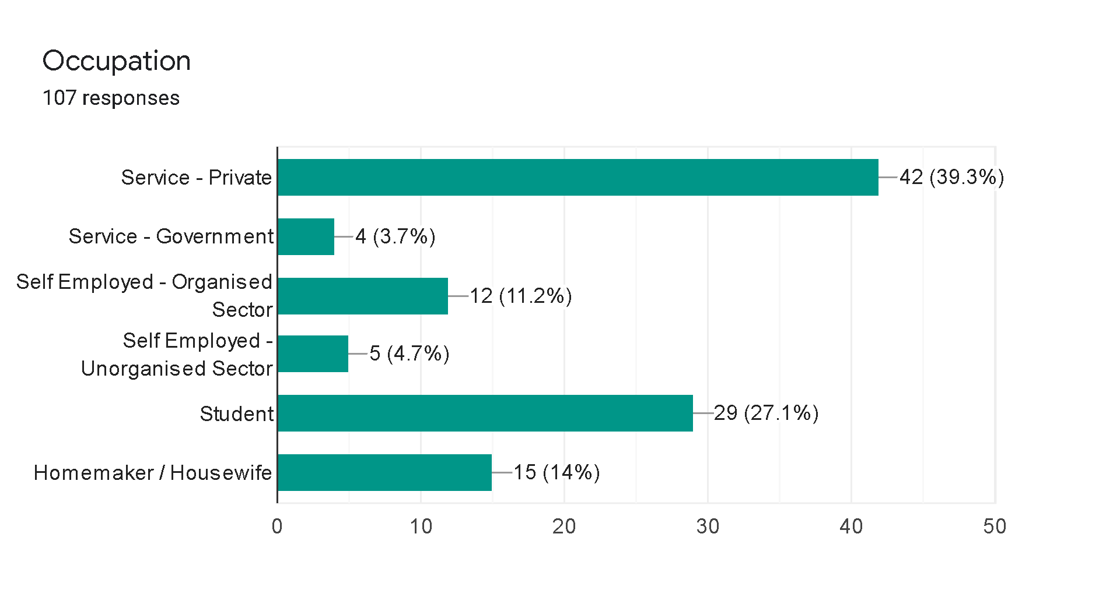

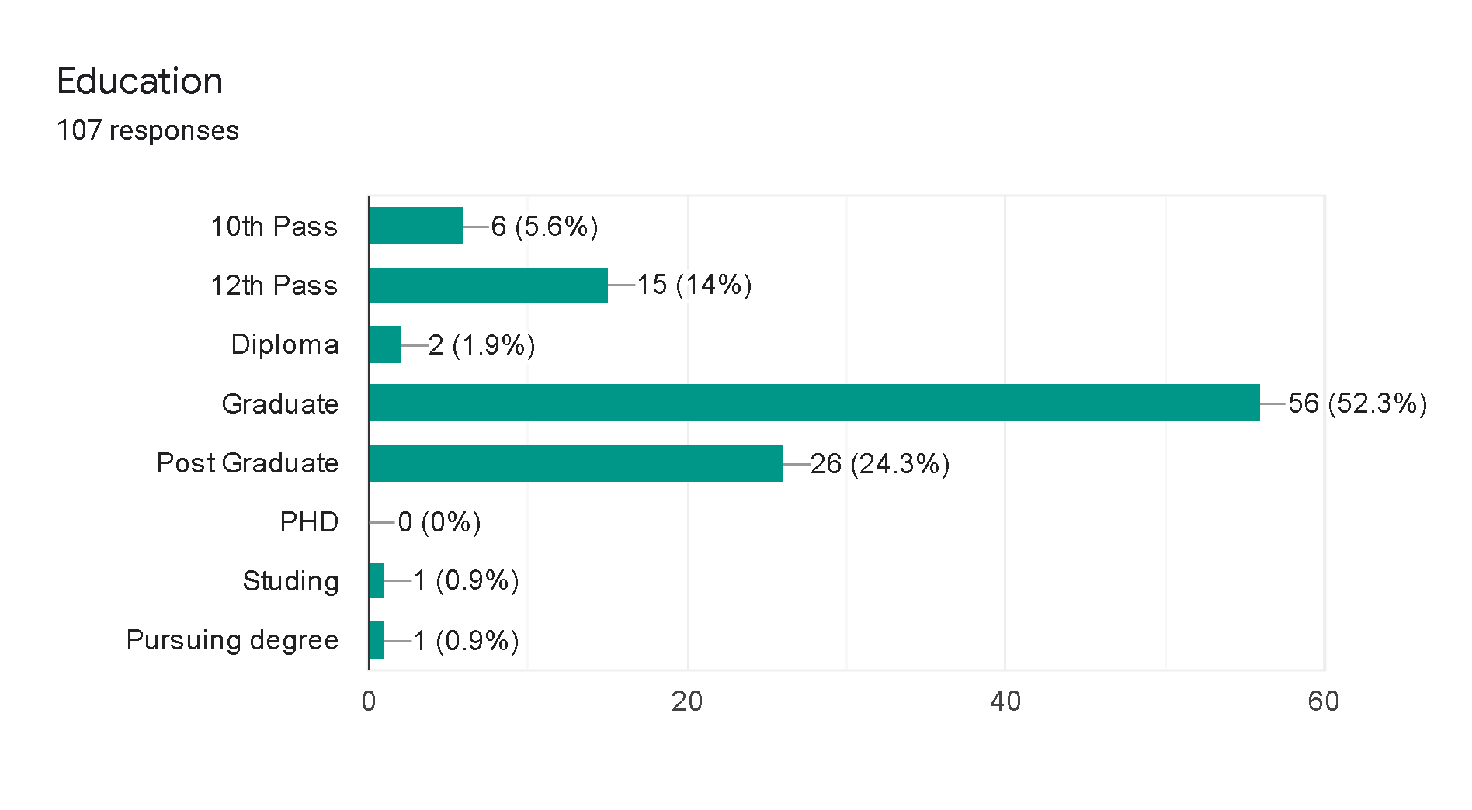

**6. Goods And Service Tax (GST)**

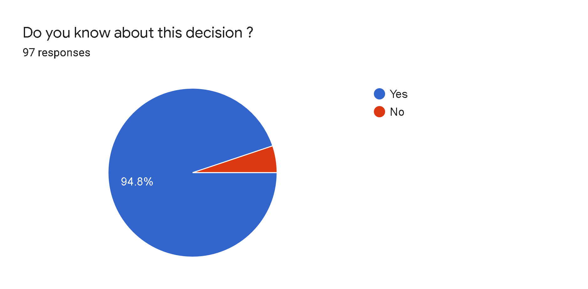

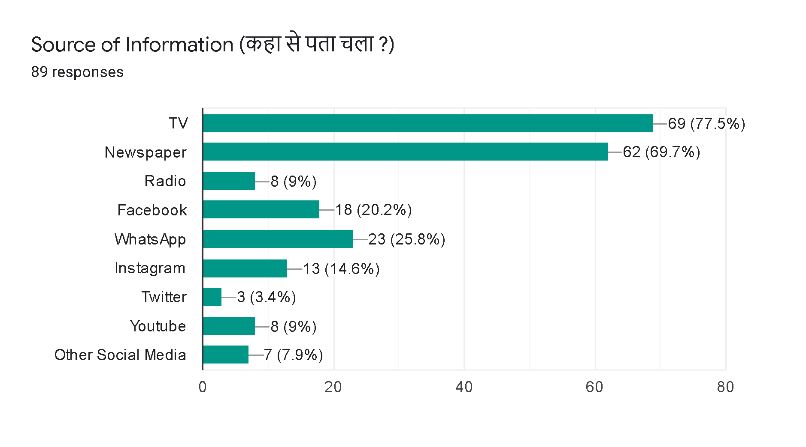

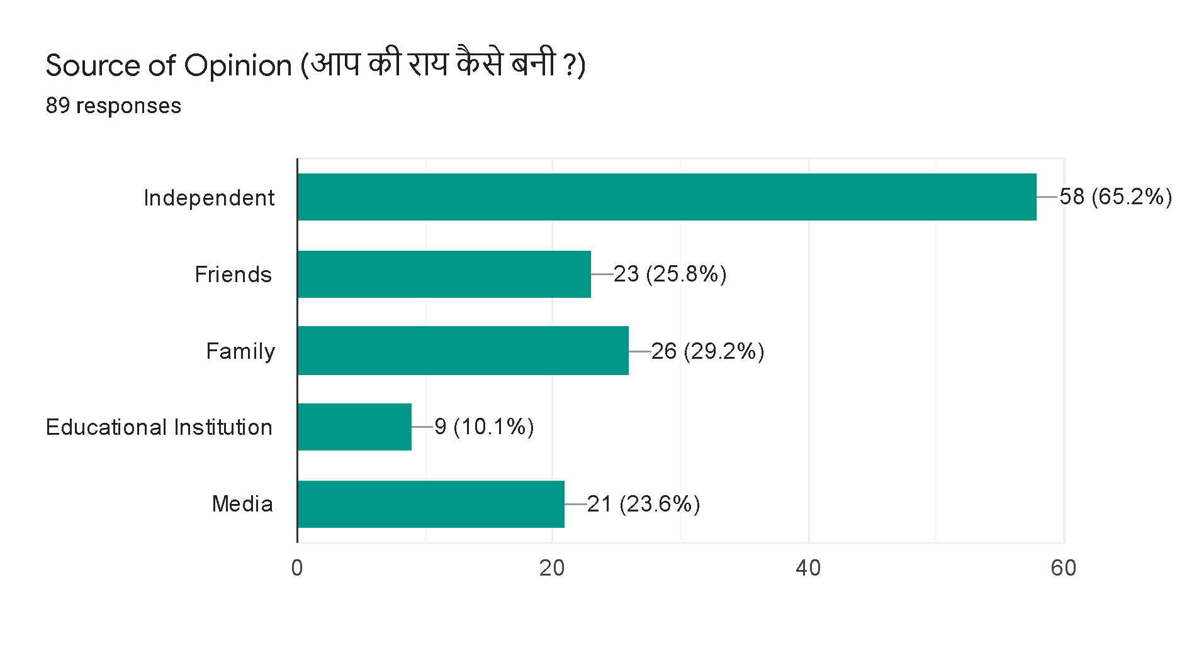

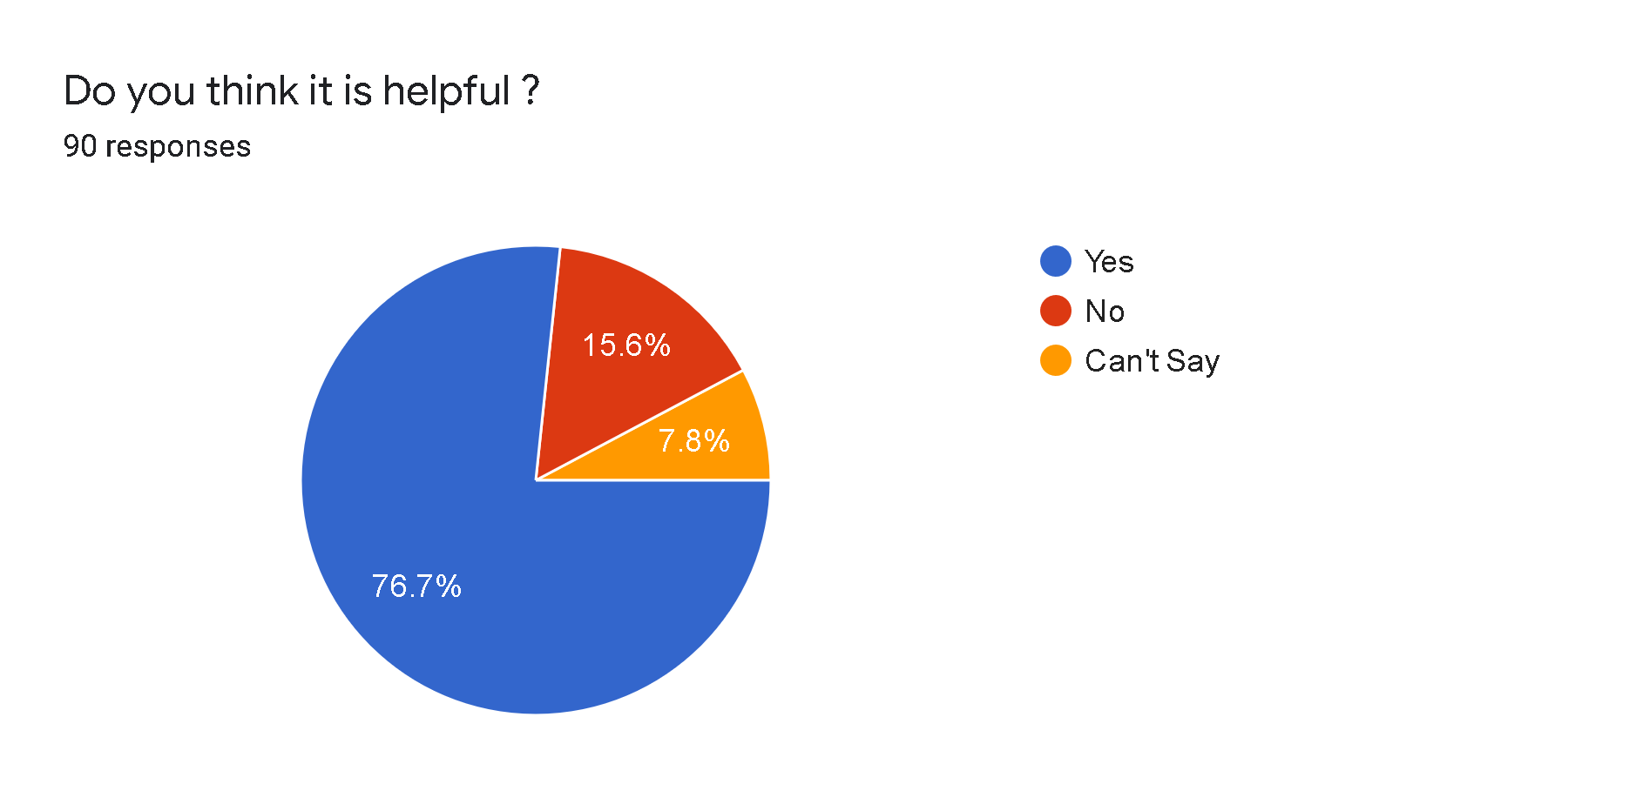

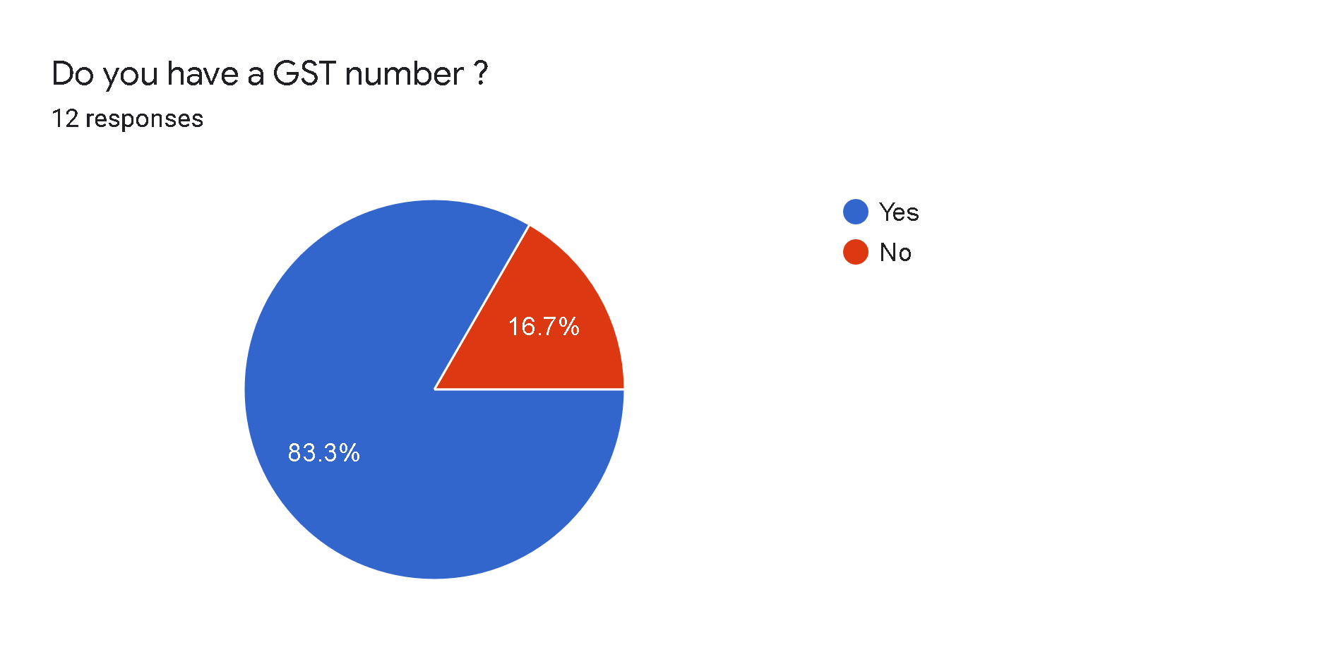

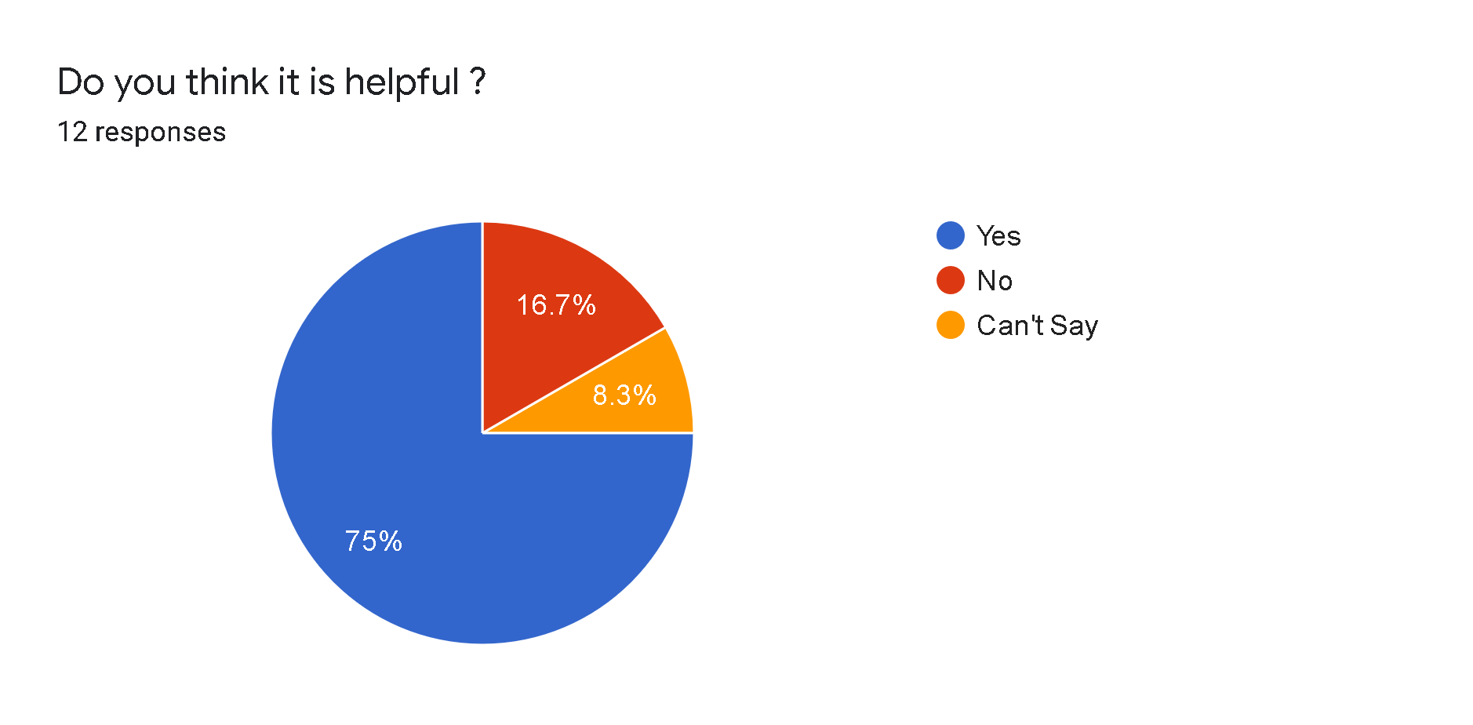

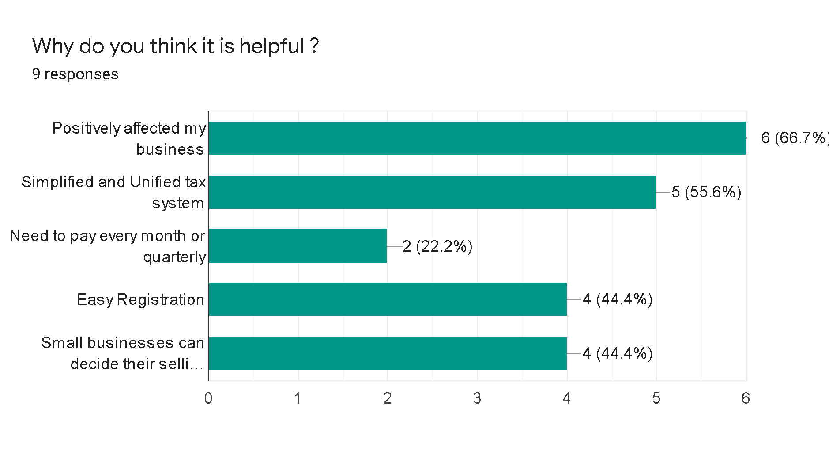

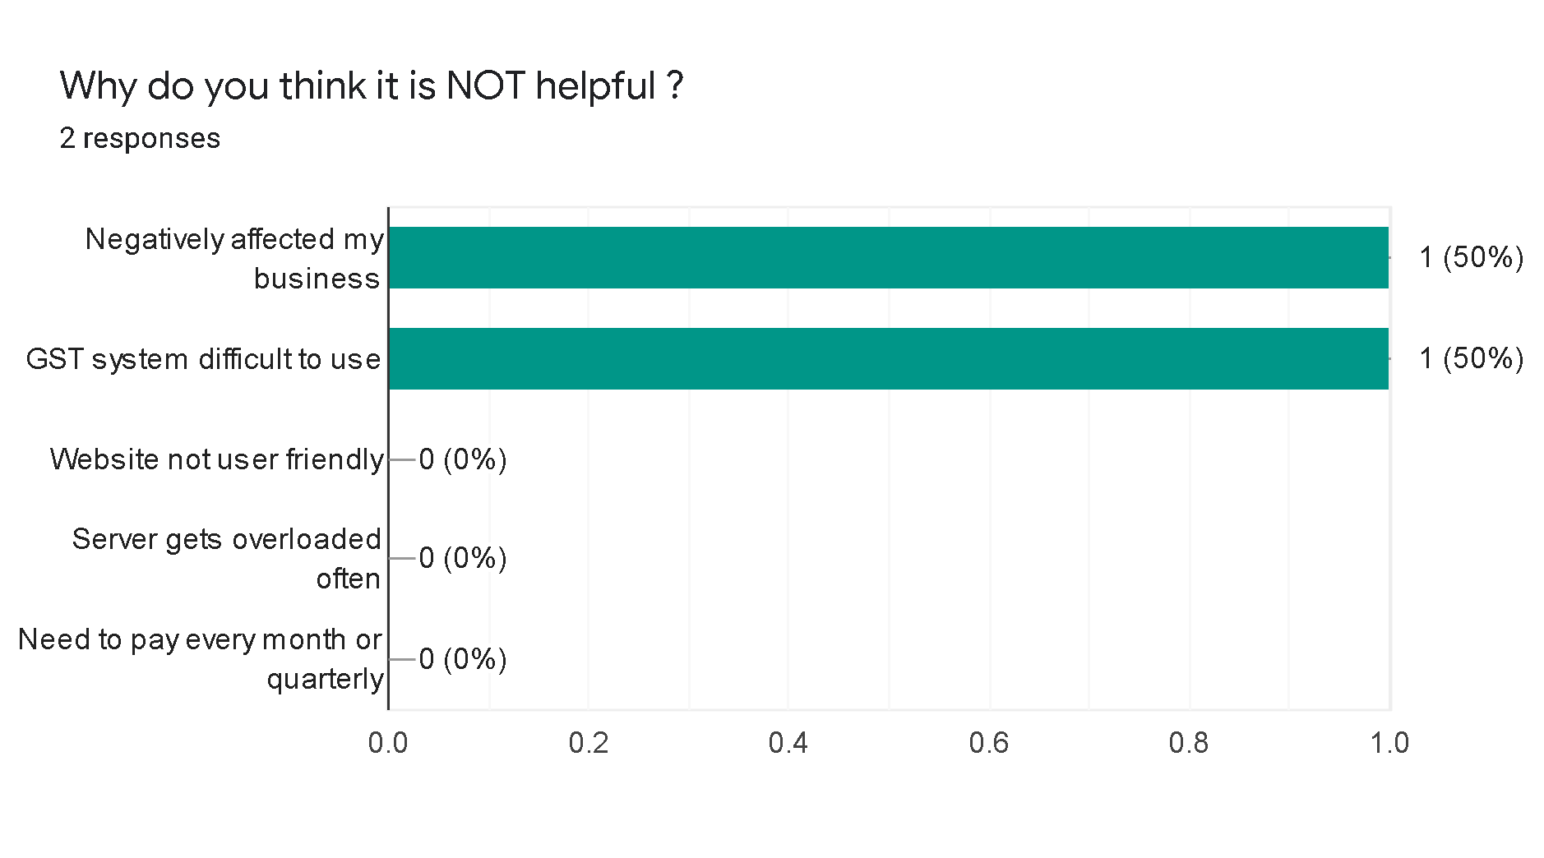

**2.2 Primary Coded Data**

|  |  |
| --- | --- |
| AGE | CODE |
| 10-20 | 1 |
| 20-30 | 2 |
| 30-40 | 3 |
| 40-50 | 4 |
| 50-60 | 5 |
| Above 60 | 6 |

AGE:

GENDER:

|  |  |
| --- | --- |
| GENDER | CODE |
| Male | 0 |
| Female | 1 |

MONTHLY INCOME:

|  |  |
| --- | --- |
| INCOME | CODE |
| Below 10,000 | 1 |
| 10k-25k | 2 |
| 25k-50k | 3 |
| 50k-1lakh | 4 |
| 1lakh Above | 5 |

OCCUPATION:

|  |  |
| --- | --- |
| OCCUPATION | CODE |
| Private | 1 |
| Government | 2 |
| Organised Sector | 3 |
| Unorganised Sector | 4 |
| Homemaker | 5 |
| Student | 6 |

EDUCATION:

|  |  |
| --- | --- |
| EDUCATION | CODE |
| 10TH Pass | 1 |
| 12TH Pass | 2 |
| Graduate | 3 |
| Post Graduate | 4 |
| Diploma | 5 |
| PHD | 6 |

**2.3 Chi-Square Test for Independence**

**HYPOTHESIS**

**H0 :** Assumes that there is no association between the two variables.

**H1 :** Assumes that there is an association between the two variables.

**Critical Region :**

Level Of Significance = 0.05

If p-value is less than or equal to 𝛂 then we reject H0

If p-value is greater than 𝛂 then we fail to reject H0

**Legend :**

Highlighted value signifies the p-value

Red : Here we reject H0

Green : Here we fail to reject H0

**4. Goods and Services Tax (GST)**

|  |  |  |  |  |  |  |
| --- | --- | --- | --- | --- | --- | --- |
| **Case Processing Summary** | | | | | | |
|  | Cases | | | | | |
|  | Valid | | Missing | | Total | |
|  | N | Percent | N | Percent | N | Percent |
| Gender * Do you know about this decision ? | 107 | 100.0% | 0 | 0.0% | 107 | 100.0% |
| Gender * Do you think it is helpful ? | 107 | 100.0% | 0 | 0.0% | 107 | 100.0% |
| Education * Do you know about this decision ? | 107 | 100.0% | 0 | 0.0% | 107 | 100.0% |
| Education * Do you think it is helpful ? | 107 | 100.0% | 0 | 0.0% | 107 | 100.0% |
| Occupation * Do you know about this decision ? | 107 | 100.0% | 0 | 0.0% | 107 | 100.0% |
| Occupation * Do you think it is helpful ? | 107 | 100.0% | 0 | 0.0% | 107 | 100.0% |
| Monthly Income * Do you know about this decision ? | 107 | 100.0% | 0 | 0.0% | 107 | 100.0% |
| Monthly Income * Do you think it is helpful ? | 107 | 100.0% | 0 | 0.0% | 107 | 100.0% |
| Age * Do you know about this decision ? | 107 | 100.0% | 0 | 0.0% | 107 | 100.0% |
| Age * Do you think it is helpful ? | 107 | 100.0% | 0 | 0.0% | 107 | 100.0% |

**Gender * Do you know about this decision ?**

|  |  |  |  |  |  |
| --- | --- | --- | --- | --- | --- |
| **Crosstab** | | | | | |
|  | | | Do you know about this decision ? | | Total |
|  | | | .00 | 1.00 |  |
| Gender | .00 | Count | 5 | 60 | 65 |
|  |  | Expected Count | 3.0 | 62.0 | 65.0 |
|  | 1.00 | Count | 0 | 42 | 42 |
|  |  | Expected Count | 2.0 | 40.0 | 42.0 |
| Total | | Count | 5 | 102 | 107 |
|  | | Expected Count | 5.0 | 102.0 | 107.0 |

|  |  |  |  |  |  |
| --- | --- | --- | --- | --- | --- |
| **Chi-Square Tests** | | | | | |
|  | Value | df | Asymp. Sig. (2-sided) | Exact Sig. (2-sided) | Exact Sig. (1-sided) |
| Pearson Chi-Square | 3.389a | 1 | .066 | .154 | .078 |
| Continuity Correctionb | 1.882 | 1 | .170 |  |  |
| Likelihood Ratio | 5.142 | 1 | .023 | .086 | .078 |
| Fisher's Exact Test |  |  |  | .154 | .078 |
| Linear-by-Linear Association | 3.357c | 1 | .067 | .154 | .078 |
| N of Valid Cases | 107 |  |  |  |  |

|  |
| --- |
| a. 2 cells (50.0%) have expected count less than 5. The minimum expected count is 1.96. |
| b. Computed only for a 2x2 table |
| c. The standardized statistic is 1.832. |

|  |  |  |  |  |
| --- | --- | --- | --- | --- |
| **Symmetric Measures** | | | | |
|  | | Value | Approx. Sig. | Exact Sig. |
| Nominal by Nominal | Phi | .178 | .066 | .154 |
|  | Cramer's V | .178 | .066 | .154 |
| N of Valid Cases | | 107 |  |  |

|  |
| --- |
| a. Not assuming the null hypothesis. |
| b. Using the asymptotic standard error assuming the null hypothesis. |

**Gender * Do you think it is helpful ?**

|  |  |  |  |  |  |  |
| --- | --- | --- | --- | --- | --- | --- |
| **Crosstab** | | | | | | |
|  | | | Do you think it is helpful ? | | | Total |
|  | | | .00 | 1.00 | 2.00 |  |
| Gender | .00 | Count | 7 | 41 | 17 | 65 |
|  |  | Expected Count | 8.5 | 41.9 | 14.6 | 65.0 |
|  | 1.00 | Count | 7 | 28 | 7 | 42 |
|  |  | Expected Count | 5.5 | 27.1 | 9.4 | 42.0 |
| Total | | Count | 14 | 69 | 24 | 107 |
|  | | Expected Count | 14.0 | 69.0 | 24.0 | 107.0 |

|  |  |  |  |  |  |
| --- | --- | --- | --- | --- | --- |
| **Chi-Square Tests** | | | | | |
|  | Value | df | Asymp. Sig. (2-sided) | Exact Sig. (2-sided) | Exact Sig. (1-sided) |
| Pearson Chi-Square | 1.753a | 2 | .416 | .430 |  |
| Likelihood Ratio | 1.778 | 2 | .411 | .430 |  |
| Fisher's Exact Test | 1.758 |  |  | .449 |  |
| Linear-by-Linear Association | 1.727b | 1 | .189 | .241 | .126 |
| N of Valid Cases | 107 |  |  |  |  |

|  |
| --- |
| a. 0 cells (0.0%) have expected count less than 5. The minimum expected count is 5.50. |
| b. The standardized statistic is -1.314. |

|  |  |  |  |  |
| --- | --- | --- | --- | --- |
| **Symmetric Measures** | | | | |
|  | | Value | Approx. Sig. | Exact Sig. |
| Nominal by Nominal | Phi | .128 | .416 | .430 |
|  | Cramer's V | .128 | .416 | .430 |
| N of Valid Cases | | 107 |  |  |

|  |
| --- |
| a. Not assuming the null hypothesis. |
| b. Using the asymptotic standard error assuming the null hypothesis. |

**Education * Do you know about this decision ?**

|  |  |  |  |  |  |
| --- | --- | --- | --- | --- | --- |
| **Crosstab** | | | | | |
|  | | | Do you know about this decision ? | | Total |
|  | | | .00 | 1.00 |  |
| Education | 1.00 | Count | 2 | 4 | 6 |
|  |  | Expected Count | .3 | 5.7 | 6.0 |
|  | 2.00 | Count | 1 | 14 | 15 |
|  |  | Expected Count | .7 | 14.3 | 15.0 |
|  | 3.00 | Count | 1 | 1 | 2 |
|  |  | Expected Count | .1 | 1.9 | 2.0 |
|  | 4.00 | Count | 0 | 56 | 56 |
|  |  | Expected Count | 2.6 | 53.4 | 56.0 |
|  | 5.00 | Count | 1 | 25 | 26 |
|  |  | Expected Count | 1.2 | 24.8 | 26.0 |
|  | 7.00 | Count | 0 | 2 | 2 |
|  |  | Expected Count | .1 | 1.9 | 2.0 |
| Total | | Count | 5 | 102 | 107 |
|  | | Expected Count | 5.0 | 102.0 | 107.0 |

|  |  |  |  |  |  |
| --- | --- | --- | --- | --- | --- |
| **Chi-Square Tests** | | | | | |
|  | Value | df | Asymp. Sig. (2-sided) | Exact Sig. (2-sided) | Exact Sig. (1-sided) |
| Pearson Chi-Square | 23.305a | 5 | .000 | .006 |  |
| Likelihood Ratio | 14.161 | 5 | .015 | .007 |  |
| Fisher's Exact Test | 16.099 |  |  | .003 |  |
| Linear-by-Linear Association | 7.261b | 1 | .007 | .010 | .009 |
| N of Valid Cases | 107 |  |  |  |  |

|  |
| --- |
| a. 8 cells (66.7%) have expected count less than 5. The minimum expected count is .09. |
| b. The standardized statistic is 2.695. |

|  |  |  |  |  |
| --- | --- | --- | --- | --- |
| **Symmetric Measures** | | | | |
|  | | Value | Approx. Sig. | Exact Sig. |
| Nominal by Nominal | Phi | .467 | .000 | .006 |
|  | Cramer's V | .467 | .000 | .006 |
| N of Valid Cases | | 107 |  |  |

|  |
| --- |
| a. Not assuming the null hypothesis. |
| b. Using the asymptotic standard error assuming the null hypothesis. |

**Education * Do you think it is helpful ?**

|  |  |  |  |  |  |  |
| --- | --- | --- | --- | --- | --- | --- |
| **Crosstab** | | | | | | |
|  | | | Do you think it is helpful ? | | | Total |
|  | | | .00 | 1.00 | 2.00 |  |
| Education | 1.00 | Count | 0 | 1 | 5 | 6 |
|  |  | Expected Count | .8 | 3.9 | 1.3 | 6.0 |
|  | 2.00 | Count | 2 | 8 | 5 | 15 |
|  |  | Expected Count | 2.0 | 9.7 | 3.4 | 15.0 |
|  | 3.00 | Count | 0 | 1 | 1 | 2 |
|  |  | Expected Count | .3 | 1.3 | .4 | 2.0 |
|  | 4.00 | Count | 9 | 40 | 7 | 56 |
|  |  | Expected Count | 7.3 | 36.1 | 12.6 | 56.0 |
|  | 5.00 | Count | 3 | 17 | 6 | 26 |
|  |  | Expected Count | 3.4 | 16.8 | 5.8 | 26.0 |
|  | 7.00 | Count | 0 | 2 | 0 | 2 |
|  |  | Expected Count | .3 | 1.3 | .4 | 2.0 |
| Total | | Count | 14 | 69 | 24 | 107 |
|  | | Expected Count | 14.0 | 69.0 | 24.0 | 107.0 |

|  |  |  |  |  |  |
| --- | --- | --- | --- | --- | --- |
| **Chi-Square Tests** | | | | | |
|  | Value | df | Asymp. Sig. (2-sided) | Exact Sig. (2-sided) | Exact Sig. (1-sided) |
| Pearson Chi-Square | 19.344a | 10 | .036 | .043 |  |
| Likelihood Ratio | 18.020 | 10 | .055 | .062 |  |
| Fisher's Exact Test | 15.849 |  |  | .049 |  |
| Linear-by-Linear Association | 5.464b | 1 | .019 | .021 | .011 |
| N of Valid Cases | 107 |  |  |  |  |

|  |
| --- |
| a. 12 cells (66.7%) have expected count less than 5. The minimum expected count is .26. |
| b. The standardized statistic is -2.337. |

|  |  |  |  |  |
| --- | --- | --- | --- | --- |
| **Symmetric Measures** | | | | |
|  | | Value | Approx. Sig. | Exact Sig. |
| Nominal by Nominal | Phi | .425 | .036 | .043 |
|  | Cramer's V | .301 | .036 | .043 |
| N of Valid Cases | | 107 |  |  |

|  |
| --- |
| a. Not assuming the null hypothesis. |
| b. Using the asymptotic standard error assuming the null hypothesis. |

**Occupation * Do you know about this decision ?**

|  |  |  |  |  |  |
| --- | --- | --- | --- | --- | --- |
| **Crosstab** | | | | | |
|  | | | Do you know about this decision ? | | Total |
|  | | | .00 | 1.00 |  |
| Occupation | 1.00 | Count | 4 | 38 | 42 |
|  |  | Expected Count | 2.0 | 40.0 | 42.0 |
|  | 2.00 | Count | 0 | 4 | 4 |
|  |  | Expected Count | .2 | 3.8 | 4.0 |
|  | 3.00 | Count | 0 | 12 | 12 |
|  |  | Expected Count | .6 | 11.4 | 12.0 |
|  | 4.00 | Count | 1 | 4 | 5 |
|  |  | Expected Count | .2 | 4.8 | 5.0 |
|  | 5.00 | Count | 0 | 29 | 29 |
|  |  | Expected Count | 1.4 | 27.6 | 29.0 |
|  | 6.00 | Count | 0 | 15 | 15 |
|  |  | Expected Count | .7 | 14.3 | 15.0 |
| Total | | Count | 5 | 102 | 107 |
|  | | Expected Count | 5.0 | 102.0 | 107.0 |

|  |  |  |  |  |  |
| --- | --- | --- | --- | --- | --- |
| **Chi-Square Tests** | | | | | |
|  | Value | df | Asymp. Sig. (2-sided) | Exact Sig. (2-sided) | Exact Sig. (1-sided) |
| Pearson Chi-Square | 7.797a | 5 | .168 | .153 |  |
| Likelihood Ratio | 8.975 | 5 | .110 | .100 |  |
| Fisher's Exact Test | 6.240 |  |  | .185 |  |
| Linear-by-Linear Association | 3.300b | 1 | .069 | .076 | .036 |
| N of Valid Cases | 107 |  |  |  |  |

|  |
| --- |
| a. 8 cells (66.7%) have expected count less than 5. The minimum expected count is .19. |
| b. The standardized statistic is 1.817. |

|  |  |  |  |  |
| --- | --- | --- | --- | --- |
| **Symmetric Measures** | | | | |
|  | | Value | Approx. Sig. | Exact Sig. |
| Nominal by Nominal | Phi | .270 | .168 | .153 |
|  | Cramer's V | .270 | .168 | .153 |
| N of Valid Cases | | 107 |  |  |

|  |
| --- |
| a. Not assuming the null hypothesis. |
| b. Using the asymptotic standard error assuming the null hypothesis. |

**Occupation * Do you think it is helpful ?**

|  |  |  |  |  |  |  |
| --- | --- | --- | --- | --- | --- | --- |
| **Crosstab** | | | | | | |
|  | | | Do you think it is helpful ? | | | Total |
|  | | | .00 | 1.00 | 2.00 |  |
| Occupation | 1.00 | Count | 5 | 27 | 10 | 42 |
|  |  | Expected Count | 5.5 | 27.1 | 9.4 | 42.0 |
|  | 2.00 | Count | 0 | 4 | 0 | 4 |
|  |  | Expected Count | .5 | 2.6 | .9 | 4.0 |
|  | 3.00 | Count | 1 | 3 | 8 | 12 |
|  |  | Expected Count | 1.6 | 7.7 | 2.7 | 12.0 |
|  | 4.00 | Count | 1 | 2 | 2 | 5 |
|  |  | Expected Count | .7 | 3.2 | 1.1 | 5.0 |
|  | 5.00 | Count | 4 | 23 | 2 | 29 |
|  |  | Expected Count | 3.8 | 18.7 | 6.5 | 29.0 |
|  | 6.00 | Count | 3 | 10 | 2 | 15 |
|  |  | Expected Count | 2.0 | 9.7 | 3.4 | 15.0 |
| Total | | Count | 14 | 69 | 24 | 107 |
|  | | Expected Count | 14.0 | 69.0 | 24.0 | 107.0 |

|  |  |  |  |  |  |
| --- | --- | --- | --- | --- | --- |
| **Chi-Square Tests** | | | | | |
|  | Value | df | Asymp. Sig. (2-sided) | Exact Sig. (2-sided) | Exact Sig. (1-sided) |
| Pearson Chi-Square | 22.429a | 10 | .013 | .014 |  |
| Likelihood Ratio | 22.038 | 10 | .015 | .022 |  |
| Fisher's Exact Test | 19.573 |  |  | .013 |  |
| Linear-by-Linear Association | 2.152b | 1 | .142 | .152 | .077 |
| N of Valid Cases | 107 |  |  |  |  |

|  |
| --- |
| a. 11 cells (61.1%) have expected count less than 5. The minimum expected count is .52. |
| b. The standardized statistic is -1.467. |

|  |  |  |  |  |
| --- | --- | --- | --- | --- |
| **Symmetric Measures** | | | | |
|  | | Value | Approx. Sig. | Exact Sig. |
| Nominal by Nominal | Phi | .458 | .013 | .014 |
|  | Cramer's V | .324 | .013 | .014 |
| N of Valid Cases | | 107 |  |  |

|  |
| --- |
| a. Not assuming the null hypothesis. |
| b. Using the asymptotic standard error assuming the null hypothesis. |

**Monthly Income * Do you know about this decision ?**

|  |  |  |  |  |  |
| --- | --- | --- | --- | --- | --- |
| **Crosstab** | | | | | |
|  | | | Do you know about this decision ? | | Total |
|  | | | .00 | 1.00 |  |
| Monthly Income | 1.00 | Count | 0 | 40 | 40 |
|  |  | Expected Count | 1.9 | 38.1 | 40.0 |
|  | 2.00 | Count | 2 | 10 | 12 |
|  |  | Expected Count | .6 | 11.4 | 12.0 |
|  | 3.00 | Count | 2 | 25 | 27 |
|  |  | Expected Count | 1.3 | 25.7 | 27.0 |
|  | 4.00 | Count | 0 | 22 | 22 |
|  |  | Expected Count | 1.0 | 21.0 | 22.0 |
|  | 5.00 | Count | 1 | 4 | 5 |
|  |  | Expected Count | .2 | 4.8 | 5.0 |
|  | 6.00 | Count | 0 | 1 | 1 |
|  |  | Expected Count | .0 | 1.0 | 1.0 |
| Total | | Count | 5 | 102 | 107 |
|  | | Expected Count | 5.0 | 102.0 | 107.0 |

|  |  |  |  |  |  |
| --- | --- | --- | --- | --- | --- |
| **Chi-Square Tests** | | | | | |
|  | Value | df | Asymp. Sig. (2-sided) | Exact Sig. (2-sided) | Exact Sig. (1-sided) |
| Pearson Chi-Square | 10.053a | 5 | .074 | .084 |  |
| Likelihood Ratio | 10.320 | 5 | .067 | .047 |  |
| Fisher's Exact Test | 10.514 |  |  | .033 |  |
| Linear-by-Linear Association | .819b | 1 | .365 | .404 | .233 |
| N of Valid Cases | 107 |  |  |  |  |

|  |
| --- |
| a. 8 cells (66.7%) have expected count less than 5. The minimum expected count is .05. |
| b. The standardized statistic is -.905. |

|  |  |  |  |  |
| --- | --- | --- | --- | --- |
| **Symmetric Measures** | | | | |
|  | | Value | Approx. Sig. | Exact Sig. |
| Nominal by Nominal | Phi | .307 | .074 | .084 |
|  | Cramer's V | .307 | .074 | .084 |
| N of Valid Cases | | 107 |  |  |

|  |
| --- |
| a. Not assuming the null hypothesis. |
| b. Using the asymptotic standard error assuming the null hypothesis. |

**Monthly Income * Do you think it is helpful ?**

|  |  |  |  |  |  |  |
| --- | --- | --- | --- | --- | --- | --- |
| **Crosstab** | | | | | | |
|  | | | Do you think it is helpful ? | | | Total |
|  | | | .00 | 1.00 | 2.00 |  |
| Monthly Income | 1.00 | Count | 7 | 28 | 5 | 40 |
|  |  | Expected Count | 5.2 | 25.8 | 9.0 | 40.0 |
|  | 2.00 | Count | 0 | 8 | 4 | 12 |
|  |  | Expected Count | 1.6 | 7.7 | 2.7 | 12.0 |
|  | 3.00 | Count | 4 | 14 | 9 | 27 |
|  |  | Expected Count | 3.5 | 17.4 | 6.1 | 27.0 |
|  | 4.00 | Count | 3 | 15 | 4 | 22 |
|  |  | Expected Count | 2.9 | 14.2 | 4.9 | 22.0 |
|  | 5.00 | Count | 0 | 3 | 2 | 5 |
|  |  | Expected Count | .7 | 3.2 | 1.1 | 5.0 |
|  | 6.00 | Count | 0 | 1 | 0 | 1 |
|  |  | Expected Count | .1 | .6 | .2 | 1.0 |
| Total | | Count | 14 | 69 | 24 | 107 |
|  | | Expected Count | 14.0 | 69.0 | 24.0 | 107.0 |

|  |  |  |  |  |  |
| --- | --- | --- | --- | --- | --- |
| **Chi-Square Tests** | | | | | |
|  | Value | df | Asymp. Sig. (2-sided) | Exact Sig. (2-sided) | Exact Sig. (1-sided) |
| Pearson Chi-Square | 9.057a | 10 | .527 | .541 |  |
| Likelihood Ratio | 11.539 | 10 | .317 | .374 |  |
| Fisher's Exact Test | 9.400 |  |  | .477 |  |
| Linear-by-Linear Association | 1.583b | 1 | .208 | .225 | .116 |
| N of Valid Cases | 107 |  |  |  |  |

|  |
| --- |
| a. 11 cells (61.1%) have expected count less than 5. The minimum expected count is .13. |
| b. The standardized statistic is 1.258. |

|  |  |  |  |  |
| --- | --- | --- | --- | --- |
| **Symmetric Measures** | | | | |
|  | | Value | Approx. Sig. | Exact Sig. |
| Nominal by Nominal | Phi | .291 | .527 | .541 |
|  | Cramer's V | .206 | .527 | .541 |
| N of Valid Cases | | 107 |  |  |

|  |
| --- |
| a. Not assuming the null hypothesis. |
| b. Using the asymptotic standard error assuming the null hypothesis. |

**Age * Do you know about this decision ?**

|  |  |  |  |  |  |
| --- | --- | --- | --- | --- | --- |
| **Crosstab** | | | | | |
|  | | | Do you know about this decision ? | | Total |
|  | | | .00 | 1.00 |  |
| Age | 1.00 | Count | 0 | 1 | 1 |
|  |  | Expected Count | .0 | 1.0 | 1.0 |
|  | 2.00 | Count | 1 | 46 | 47 |
|  |  | Expected Count | 2.2 | 44.8 | 47.0 |
|  | 3.00 | Count | 1 | 15 | 16 |
|  |  | Expected Count | .7 | 15.3 | 16.0 |
|  | 4.00 | Count | 0 | 25 | 25 |
|  |  | Expected Count | 1.2 | 23.8 | 25.0 |
|  | 5.00 | Count | 3 | 10 | 13 |
|  |  | Expected Count | .6 | 12.4 | 13.0 |
|  | 6.00 | Count | 0 | 5 | 5 |
|  |  | Expected Count | .2 | 4.8 | 5.0 |
| Total | | Count | 5 | 102 | 107 |
|  | | Expected Count | 5.0 | 102.0 | 107.0 |

|  |  |  |  |  |  |
| --- | --- | --- | --- | --- | --- |
| **Chi-Square Tests** | | | | | |
|  | Value | Df | Asymp. Sig. (2-sided) | Exact Sig. (2-sided) | Exact Sig. (1-sided) |
| Pearson Chi-Square | 12.177a | 5 | .032 | .077 |  |
| Likelihood Ratio | 9.191 | 5 | .102 | .079 |  |
| Fisher's Exact Test | 9.430 |  |  | .067 |  |
| Linear-by-Linear Association | 2.310b | 1 | .129 | .147 | .097 |
| N of Valid Cases | 107 |  |  |  |  |

|  |
| --- |
| a. 8 cells (66.7%) have expected count less than 5. The minimum expected count is .05. |
| b. The standardized statistic is -1.520. |

|  |  |  |  |  |
| --- | --- | --- | --- | --- |
| **Symmetric Measures** | | | | |
|  | | Value | Approx. Sig. | Exact Sig. |
| Nominal by Nominal | Phi | .337 | .032 | .077 |
|  | Cramer's V | .337 | .032 | .077 |
| N of Valid Cases | | 107 |  |  |

|  |
| --- |
| a. Not assuming the null hypothesis. |
| b. Using the asymptotic standard error assuming the null hypothesis. |

**Age * Do you think it is helpful ?**

|  |  |  |  |  |  |  |
| --- | --- | --- | --- | --- | --- | --- |
| **Crosstab** | | | | | | |
|  | | | Do you think it is helpful ? | | | Total |
|  | | | .00 | 1.00 | 2.00 |  |
| Age | 1.00 | Count | 0 | 1 | 0 | 1 |
|  |  | Expected Count | .1 | .6 | .2 | 1.0 |
|  | 2.00 | Count | 7 | 34 | 6 | 47 |
|  |  | Expected Count | 6.1 | 30.3 | 10.5 | 47.0 |
|  | 3.00 | Count | 2 | 7 | 7 | 16 |
|  |  | Expected Count | 2.1 | 10.3 | 3.6 | 16.0 |
|  | 4.00 | Count | 3 | 17 | 5 | 25 |
|  |  | Expected Count | 3.3 | 16.1 | 5.6 | 25.0 |
|  | 5.00 | Count | 2 | 6 | 5 | 13 |
|  |  | Expected Count | 1.7 | 8.4 | 2.9 | 13.0 |
|  | 6.00 | Count | 0 | 4 | 1 | 5 |
|  |  | Expected Count | .7 | 3.2 | 1.1 | 5.0 |
| Total | | Count | 14 | 69 | 24 | 107 |
|  | | Expected Count | 14.0 | 69.0 | 24.0 | 107.0 |

|  |  |  |  |  |  |
| --- | --- | --- | --- | --- | --- |
| **Chi-Square Tests** | | | | | |
|  | Value | df | Asymp. Sig. (2-sided) | Exact Sig. (2-sided) | Exact Sig. (1-sided) |
| Pearson Chi-Square | 10.598a | 10 | .390 | .403 |  |
| Likelihood Ratio | 11.143 | 10 | .346 | .414 |  |
| Fisher's Exact Test | 10.802 |  |  | .330 |  |
| Linear-by-Linear Association | 1.820b | 1 | .177 | .196 | .100 |
| N of Valid Cases | 107 |  |  |  |  |

|  |
| --- |
| a. 11 cells (61.1%) have expected count less than 5. The minimum expected count is .13. |
| b. The standardized statistic is 1.349. |

|  |  |  |  |  |
| --- | --- | --- | --- | --- |
| **Symmetric Measures** | | | | |
|  | | Value | Approx. Sig. | Exact Sig. |
| Nominal by Nominal | Phi | .315 | .390 | .403 |
|  | Cramer's V | .223 | .390 | .403 |
| N of Valid Cases | | 107 |  |  |

|  |
| --- |
| a. Not assuming the null hypothesis. |
| b. Using the asymptotic standard error assuming the null hypothesis. |

|  |  |  |
| --- | --- | --- |
|  | **Association** | **No Association** |
| **1.Pradhan Mantri Awas Yojana** | Education* Awareness | Gender * Awareness |
|  | Education* Helpful | Gender * Helpful |
|  | Occupation*Awareness | Occupation*Helpful |
|  | Age* Awareness | Monthly Income*Awareness |
|  |  | Monthly Income*Helpful |
|  |  | Age*Helpful |
| **2.Demonitisation** | Age* Awareness | Gender * Awareness |
|  | Education* Awareness | Gender * Helpfu |
|  | Occupation*Helpful | Age*Helpful |
|  |  | Monthly Income*Awareness |
|  |  | Monthly Income*Helpful |
|  |  | Occupation*Awareness |
|  |  | Education* Helpful |
| **3.Surgical Strick (Uri)** |  | Age* Awareness |
|  |  | Gender * Awareness |
|  |  | Occupation*Awareness |
|  |  | Monthly Income*Awareness |
|  |  | Education* Awareness |
| **4.Goods and Service Tax** | Education* Awareness | Gender * Awareness |
|  | Education* Helpful | Gender * Helpful |
|  | Occupation*Helpful | Occupation*Awareness |
|  | Monthly Income*Awareness | Monthly Income*Helpful |
|  |  | Age*Helpful |
|  |  | Age*Awareness |
| **5.Air Strick (Pulwama)** | Education* Awareness | Age*Helpful |
|  |  | Age*Awareness |
|  |  | Monthly Income*Awareness |
|  |  | Gender * Awareness |
| **6. Motor Vehicle Act** | Occupation*Awareness | Age*Helpful |
|  | Occupation*Helpful | Age*Awareness |
|  |  | Monthly Income* Helpful |
|  |  | Monthly Income* Awareness |
|  |  | Gender * Helpful |
|  |  | Gender * Awareness |
|  |  | Education* Helpful |
|  |  | Education* Awareness |

**2.4 Multiple Response Analysis**

**4. Goods and Services Tax (GST)**

|  |  |  |  |  |  |  |
| --- | --- | --- | --- | --- | --- | --- |
| **Case Summary** | | | | | | |
|  | Cases | | | | | |
| Valid | | Missing | | Total | |
| N | Percent | N | Percent | N | Percent |
| Age*$Source_Of_opinion*Gender | 72 | 58.1% | 52 | 41.9% | 124 | 100.0% |

|  |  |  |  |  |  |  |  |  |
| --- | --- | --- | --- | --- | --- | --- | --- | --- |
| **Age*$Source_Of_opinion*Gender Crosstabulation** | | | | | | | | |
| Gender | | | | Source_Of_opiniona | | | | Total |
| Independent | Friends | Educational | Media |
| .00 | Age | 2.00 | Count | 19 | 5 | 4 | 9 | 23 |
| 3.00 | Count | 3 | 1 | 0 | 1 | 4 |
| 4.00 | Count | 8 | 0 | 0 | 3 | 10 |
| 5.00 | Count | 4 | 0 | 0 | 1 | 5 |
| 6.00 | Count | 0 | 0 | 0 | 1 | 1 |
| Total | | Count | 34 | 6 | 4 | 15 | 43 |
| 1.00 | Age | 1.00 | Count | 1 | 1 | 1 | 1 | 1 |
| 2.00 | Count | 9 | 3 | 1 | 3 | 12 |
| 3.00 | Count | 5 | 0 | 0 | 1 | 6 |
| 4.00 | Count | 6 | 2 | 1 | 0 | 6 |
| 5.00 | Count | 2 | 0 | 0 | 1 | 3 |
| 6.00 | Count | 1 | 0 | 0 | 0 | 1 |
| Total | | Count | 24 | 6 | 3 | 6 | 29 |

|  |  |  |  |  |  |  |
| --- | --- | --- | --- | --- | --- | --- |
| **Case Summary** | | | | | | |
|  | Cases | | | | | |
| Valid | | Missing | | Total | |
| N | Percent | N | Percent | N | Percent |
| Age*$Source_Of_Information*Gender | 89 | 71.8% | 35 | 28.2% | 124 | 100.0% |

|  |  |  |  |  |  |  |  |  |  |  |  |  |  |  |
| --- | --- | --- | --- | --- | --- | --- | --- | --- | --- | --- | --- | --- | --- | --- |
| **Age*$Source_Of_Information*Gender Crosstabulation** | | | | | | | | | | | | | | |
| Gender | | | | Source_Of_Informationa | | | | |  |  |  |  |  |
| Newspaper | TV | Radio | facebook | whatsapp |  |  |  |  |  |
| .00 | Age | 2.0 | Count | 19 | 19 | 2 | 7 | 8 |  |  |  |  |  |
| 3.0 | Count | 3 | 4 | 0 | 2 | 2 |  |  |  |  |  |
| 4.0 | Count | 9 | 9 | 3 | 2 | 2 |  |  |  |  |  |
| 5.0 | Count | 4 | 4 | 0 | 0 | 0 |  |  |  |  |  |
| 6.0 | Count | 0 | 1 | 0 | 1 | 0 |  |  |  |  |  |
| Total | | Count | 35 | 37 | 5 | 12 | 12 |  |  |  |  |  |
| 1.00 | Age | 1.0 | Count | 1 | 1 | 1 | 0 | 1 |  |  |  |  |  |
| 2.0 | Count | 13 | 15 | 2 | 3 | 3 |  |  |  |  |  |
| 3.0 | Count | 2 | 3 | 0 | 1 | 2 |  |  |  |  |  |
| 4.0 | Count | 7 | 7 | 0 | 0 | 4 |  |  |  |  |  |
| 5.0 | Count | 1 | 3 | 0 | 1 | 0 |  |  |  |  |  |
| 6.0 | Count | 3 | 3 | 0 | 1 | 1 |  |  |  |  |  |
| Total | | Count | 27 | 32 | 3 | 6 | 11 |  |  |  |  |  |

|  |  |  |  |  |  |  |
| --- | --- | --- | --- | --- | --- | --- |
| **Case Summary** | | | | | | |
|  | Cases | | | | | |
| Valid | | Missing | | Total | |
| N | Percent | N | Percent | N | Percent |
| Gender*Income*$ReasonsForOpinion | 11 | 10.3% | 96 | 89.7% | 107 | 100.0% |

|  |  |  |  |  |  |  |  |
| --- | --- | --- | --- | --- | --- | --- | --- |
| **Gender*Income*$ReasonsForOpinion Crosstabulation** | | | | | | | |
| ReasonsForOpiniona | | | | Income | | | |
| 1.00 | 2.00 | 3.00 | 4.00 |
| Positively_affected_my_business | Gender | .00 | Count | 0 | 1 | 0 | 3 |
| 1.00 | Count | 1 | 0 | 1 | 0 |
| Total | | Count | 1 | 1 | 1 | 3 |
| Simplified_and_Unified_tax_system | Gender | .00 | Count |  | 2 | 1 | 1 |
| 1.00 | Count |  | 0 | 1 | 0 |
| Total | | Count |  | 2 | 2 | 1 |
| Need_to_pay_regularly | Gender | .00 | Count |  |  | 1 |  |
| 1.00 | Count |  |  | 1 |  |
| Total | | Count |  |  | 2 |  |
| Easy_Registration | Gender | .00 | Count |  | 1 | 2 |  |
| 1.00 | Count |  | 0 | 1 |  |
| Total | | Count |  | 1 | 3 |  |
| Can_decide_their_selling_price | Gender | .00 | Count |  | 1 | 1 | 1 |
| 1.00 | Count |  | 0 | 1 | 0 |
| Total | | Count |  | 1 | 2 | 1 |
| Negatively_affected_my_business | Gender | .00 | Count |  |  | 1 |  |
| Total | | Count |  |  | 1 |  |
| Difficult_to_use | Gender | .00 | Count |  | 1 |  |  |
| Total | | Count |  | 1 |  |  |

|  |  |  |  |  |
| --- | --- | --- | --- | --- |
| **Gender*Income*$ReasonsForOpinion Crosstabulation** | | | | |
| ReasonsForOpiniona | | | | Total |
|  |
| Positively_affected_my_business | Gender | .00 | Count | 4 |  |
| 1.00 | Count | 2 |  |
| Total | | Count | 6 |  |
| Simplified_and_Unified_tax_system | Gender | .00 | Count | 4 |  |
| 1.00 | Count | 1 |  |
| Total | | Count | 5 |  |
| Need_to_pay_regularly | Gender | .00 | Count | 1 |  |
| 1.00 | Count | 1 |  |
| Total | | Count | 2 |  |
| Easy_Registration | Gender | .00 | Count | 3 |  |
| 1.00 | Count | 1 |  |
| Total | | Count | 4 |  |
| Can_decide_their_selling_price | Gender | .00 | Count | 3 |  |
| 1.00 | Count | 1 |  |
| Total | | Count | 4 |  |
| Negatively_affected_my_business | Gender | .00 | Count | 1 |  |
| Total | | Count | 1 |  |
| Difficult_to_use | Gender | .00 | Count | 1 |  |
| Total | | Count | 1 |  |

|  |
| --- |
| Percentages and totals are based on respondents. |
| a. Dichotomy group tabulated at value 1. |

|  |  |  |  |  |  |  |  |
| --- | --- | --- | --- | --- | --- | --- | --- |
| **Gender*Occupation*$ReasonsForOpinion Crosstabulation** | | | | | | | |
| ReasonsForOpiniona | | | | Occupation | | | Total |
| 1.00 | 3.00 | 4.00 |
| Positively_affected_my_business | Gender | .00 | Count | 1 | 3 |  | 4 |
| 1.00 | Count | 0 | 2 |  | 2 |
| Total | | Count | 1 | 5 |  | 6 |
| Simplified_and_Unified_tax_system | Gender | .00 | Count | 1 | 2 | 1 | 4 |
| 1.00 | Count | 0 | 1 | 0 | 1 |
| Total | | Count | 1 | 3 | 1 | 5 |
| Need_to_pay_regularly | Gender | .00 | Count | 1 | 0 |  | 1 |
| 1.00 | Count | 0 | 1 |  | 1 |
| Total | | Count | 1 | 1 |  | 2 |
| Easy_Registration | Gender | .00 | Count | 1 | 2 |  | 3 |
| 1.00 | Count | 0 | 1 |  | 1 |
| Total | | Count | 1 | 3 |  | 4 |
| Can_decide_their_selling_price | Gender | .00 | Count | 1 | 2 |  | 3 |
| 1.00 | Count | 0 | 1 |  | 1 |
| Total | | Count | 1 | 3 |  | 4 |
| Negatively_affected_my_business | Gender | .00 | Count |  | 1 |  | 1 |
| Total | | Count |  | 1 |  | 1 |
| Difficult_to_use | Gender | .00 | Count | 1 |  |  | 1 |
| Total | | Count | 1 |  |  | 1 |

|  |
| --- |
| Percentages and totals are based on respondents. |
| a. Dichotomy group tabulated at value 1. |

|  |  |  |  |  |  |  |  |
| --- | --- | --- | --- | --- | --- | --- | --- |
| **Gender*Education*$ReasonsForOpinion Crosstabulation** | | | | | | | |
| ReasonsForOpiniona | | | | Education | | | |
| 1.00 | 2.00 | 3.00 | 4.00 |
| Positively_affected_my_business | Gender | .00 | Count | 2 |  |  | 2 |
| 1.00 | Count | 1 |  |  | 0 |
| Total | | Count | 3 |  |  | 2 |
| Simplified_and_Unified_tax_system | Gender | .00 | Count | 1 |  |  | 2 |
| 1.00 | Count | 0 |  |  | 0 |
| Total | | Count | 1 |  |  | 2 |
| Need_to_pay_regularly | Gender | .00 | Count |  | 1 |  |  |
| 1.00 | Count |  | 0 |  |  |
| Total | | Count |  | 1 |  |  |
| Easy_Registration | Gender | .00 | Count | 1 | 1 |  |  |
| 1.00 | Count | 0 | 0 |  |  |
| Total | | Count | 1 | 1 |  |  |
| Can_decide_their_selling_price | Gender | .00 | Count | 1 |  |  | 1 |
| 1.00 | Count | 0 |  |  | 0 |
| Total | | Count | 1 |  |  | 1 |
| Negatively_affected_my_business | Gender | .00 | Count |  | 1 |  |  |
| Total | | Count |  | 1 |  |  |
| Difficult_to_use | Gender | .00 | Count |  |  | 1 |  |
| Total | | Count |  |  | 1 |  |

|  |  |  |  |  |  |
| --- | --- | --- | --- | --- | --- |
| **Gender*Education*$ReasonsForOpinion Crosstabulation** | | | | | |
| ReasonsForOpiniona | | | | Education | Total |
| 5.00 |
| Positively_affected_my_business | Gender | .00 | Count | 0 | 4 |
| 1.00 | Count | 1 | 2 |
| Total | | Count | 1 | 6 |
| Simplified_and_Unified_tax_system | Gender | .00 | Count | 1 | 4 |
| 1.00 | Count | 1 | 1 |
| Total | | Count | 2 | 5 |
| Need_to_pay_regularly | Gender | .00 | Count | 0 | 1 |
| 1.00 | Count | 1 | 1 |
| Total | | Count | 1 | 2 |
| Easy_Registration | Gender | .00 | Count | 1 | 3 |
| 1.00 | Count | 1 | 1 |
| Total | | Count | 2 | 4 |
| Can_decide_their_selling_price | Gender | .00 | Count | 1 | 3 |
| 1.00 | Count | 1 | 1 |
| Total | | Count | 2 | 4 |
| Negatively_affected_my_business | Gender | .00 | Count |  | 1 |
| Total | | Count |  | 1 |
| Difficult_to_use | Gender | .00 | Count |  | 1 |
| Total | | Count |  | 1 |

|  |
| --- |
| Percentages and totals are based on respondents. |
| a. Dichotomy group tabulated at value 1. |

|  |  |  |  |  |  |  |  |
| --- | --- | --- | --- | --- | --- | --- | --- |
| **Age*Income*$ReasonsForOpinion Crosstabulation** | | | | | | | |
| ReasonsForOpiniona | | | | Income | | | |
| 1.00 | 2.00 | 3.00 | 4.00 |
| Positively_affected_my_business | Age | 2.00 | Count | 0 | 0 | 0 | 1 |
| 4.00 | Count | 1 | 1 | 0 | 0 |
| 5.00 | Count | 0 | 0 | 0 | 2 |
| 6.00 | Count | 0 | 0 | 1 | 0 |
| Total | | Count | 1 | 1 | 1 | 3 |
| Simplified_and_Unified_tax_system | Age | 2.00 | Count |  | 1 | 0 | 1 |
| 3.00 | Count |  | 0 | 1 | 0 |
| 4.00 | Count |  | 1 | 0 | 0 |
| 6.00 | Count |  | 0 | 1 | 0 |
| Total | | Count |  | 2 | 2 | 1 |
| Need_to_pay_regularly | Age | 3.00 | Count |  |  | 1 |  |
| 6.00 | Count |  |  | 1 |  |
| Total | | Count |  |  | 2 |  |
| Easy_Registration | Age | 3.00 | Count |  | 0 | 2 |  |
| 4.00 | Count |  | 1 | 0 |  |
| 6.00 | Count |  | 0 | 1 |  |
| Total | | Count |  | 1 | 3 |  |
| Can_decide_their_selling_price | Age | 2.00 | Count |  | 0 | 0 | 1 |
| 3.00 | Count |  | 0 | 1 | 0 |
| 4.00 | Count |  | 1 | 0 | 0 |
| 6.00 | Count |  | 0 | 1 | 0 |
| Total | | Count |  | 1 | 2 | 1 |
| Negatively_affected_my_business | Age | 4.00 | Count |  |  | 1 |  |
| Total | | Count |  |  | 1 |  |
| Difficult_to_use | Age | 2.00 | Count |  | 1 |  |  |
| Total | | Count |  | 1 |  |  |

|  |  |  |  |  |
| --- | --- | --- | --- | --- |
| **Age*Income*$ReasonsForOpinion Crosstabulation** | | | | |
| ReasonsForOpiniona | | | | Total |
|  |
| Positively_affected_my_business | Age | 2.00 | Count | 1 |  |
| 4.00 | Count | 2 |  |
| 5.00 | Count | 2 |  |
| 6.00 | Count | 1 |  |
| Total | | Count | 6 |  |
| Simplified_and_Unified_tax_system | Age | 2.00 | Count | 2 |  |
| 3.00 | Count | 1 |  |
| 4.00 | Count | 1 |  |
| 6.00 | Count | 1 |  |
| Total | | Count | 5 |  |
| Need_to_pay_regularly | Age | 3.00 | Count | 1 |  |
| 6.00 | Count | 1 |  |
| Total | | Count | 2 |  |
| Easy_Registration | Age | 3.00 | Count | 2 |  |
| 4.00 | Count | 1 |  |
| 6.00 | Count | 1 |  |
| Total | | Count | 4 |  |
| Can_decide_their_selling_price | Age | 2.00 | Count | 1 |  |
| 3.00 | Count | 1 |  |
| 4.00 | Count | 1 |  |
| 6.00 | Count | 1 |  |
| Total | | Count | 4 |  |
| Negatively_affected_my_business | Age | 4.00 | Count | 1 |  |
| Total | | Count | 1 |  |
| Difficult_to_use | Age | 2.00 | Count | 1 |  |
| Total | | Count | 1 |  |

|  |
| --- |
| Percentages and totals are based on respondents. |
| a. Dichotomy group tabulated at value 1. |

|  |  |  |  |  |  |  |  |
| --- | --- | --- | --- | --- | --- | --- | --- |
| **Age*Occupation*$ReasonsForOpinion Crosstabulation** | | | | | | | |
| ReasonsForOpiniona | | | | Occupation | | | Total |
| 1.00 | 3.00 | 4.00 |
| Positively_affected_my_business | Age | 2.00 | Count | 1 | 0 |  | 1 |
| 4.00 | Count | 0 | 2 |  | 2 |
| 5.00 | Count | 0 | 2 |  | 2 |
| 6.00 | Count | 0 | 1 |  | 1 |
| Total | | Count | 1 | 5 |  | 6 |
| Simplified_and_Unified_tax_system | Age | 2.00 | Count | 1 | 0 | 1 | 2 |
| 3.00 | Count | 0 | 1 | 0 | 1 |
| 4.00 | Count | 0 | 1 | 0 | 1 |
| 6.00 | Count | 0 | 1 | 0 | 1 |
| Total | | Count | 1 | 3 | 1 | 5 |
| Need_to_pay_regularly | Age | 3.00 | Count | 1 | 0 |  | 1 |
| 6.00 | Count | 0 | 1 |  | 1 |
| Total | | Count | 1 | 1 |  | 2 |
| Easy_Registration | Age | 3.00 | Count | 1 | 1 |  | 2 |
| 4.00 | Count | 0 | 1 |  | 1 |
| 6.00 | Count | 0 | 1 |  | 1 |
| Total | | Count | 1 | 3 |  | 4 |
| Can_decide_their_selling_price | Age | 2.00 | Count | 1 | 0 |  | 1 |
| 3.00 | Count | 0 | 1 |  | 1 |
| 4.00 | Count | 0 | 1 |  | 1 |
| 6.00 | Count | 0 | 1 |  | 1 |
| Total | | Count | 1 | 3 |  | 4 |
| Negatively_affected_my_business | Age | 4.00 | Count |  | 1 |  | 1 |
| Total | | Count |  | 1 |  | 1 |
| Difficult_to_use | Age | 2.00 | Count | 1 |  |  | 1 |
| Total | | Count | 1 |  |  | 1 |

|  |
| --- |
| Percentages and totals are based on respondents. |
| a. Dichotomy group tabulated at value 1. |

|  |  |  |  |  |  |  |  |
| --- | --- | --- | --- | --- | --- | --- | --- |
| **Age*Education*$ReasonsForOpinion Crosstabulation** | | | | | | | |
| ReasonsForOpiniona | | | | Education | | | |
| 1.00 | 2.00 | 3.00 | 4.00 |
| Positively_affected_my_business | Age | 2.00 | Count | 0 |  |  | 1 |
| 4.00 | Count | 2 |  |  | 0 |
| 5.00 | Count | 1 |  |  | 1 |
| 6.00 | Count | 0 |  |  | 0 |
| Total | | Count | 3 |  |  | 2 |
| Simplified_and_Unified_tax_system | Age | 2.00 | Count | 0 |  |  | 2 |
| 3.00 | Count | 0 |  |  | 0 |
| 4.00 | Count | 1 |  |  | 0 |
| 6.00 | Count | 0 |  |  | 0 |
| Total | | Count | 1 |  |  | 2 |
| Need_to_pay_regularly | Age | 3.00 | Count |  | 1 |  |  |
| 6.00 | Count |  | 0 |  |  |
| Total | | Count |  | 1 |  |  |
| Easy_Registration | Age | 3.00 | Count | 0 | 1 |  |  |
| 4.00 | Count | 1 | 0 |  |  |
| 6.00 | Count | 0 | 0 |  |  |
| Total | | Count | 1 | 1 |  |  |
| Can_decide_their_selling_price | Age | 2.00 | Count | 0 |  |  | 1 |
| 3.00 | Count | 0 |  |  | 0 |
| 4.00 | Count | 1 |  |  | 0 |
| 6.00 | Count | 0 |  |  | 0 |
| Total | | Count | 1 |  |  | 1 |
| Negatively_affected_my_business | Age | 4.00 | Count |  | 1 |  |  |
| Total | | Count |  | 1 |  |  |
| Difficult_to_use | Age | 2.00 | Count |  |  | 1 |  |
| Total | | Count |  |  | 1 |  |

|  |  |  |  |  |  |
| --- | --- | --- | --- | --- | --- |
| **Age*Education*$ReasonsForOpinion Crosstabulation** | | | | | |
| ReasonsForOpiniona | | | | Education | Total |
| 5.00 |
| Positively_affected_my_business | Age | 2.00 | Count | 0 | 1 |
| 4.00 | Count | 0 | 2 |
| 5.00 | Count | 0 | 2 |
| 6.00 | Count | 1 | 1 |
| Total | | Count | 1 | 6 |
| Simplified_and_Unified_tax_system | Age | 2.00 | Count | 0 | 2 |
| 3.00 | Count | 1 | 1 |
| 4.00 | Count | 0 | 1 |
| 6.00 | Count | 1 | 1 |
| Total | | Count | 2 | 5 |
| Need_to_pay_regularly | Age | 3.00 | Count | 0 | 1 |
| 6.00 | Count | 1 | 1 |
| Total | | Count | 1 | 2 |
| Easy_Registration | Age | 3.00 | Count | 1 | 2 |
| 4.00 | Count | 0 | 1 |
| 6.00 | Count | 1 | 1 |
| Total | | Count | 2 | 4 |
| Can_decide_their_selling_price | Age | 2.00 | Count | 0 | 1 |
| 3.00 | Count | 1 | 1 |
| 4.00 | Count | 0 | 1 |
| 6.00 | Count | 1 | 1 |
| Total | | Count | 2 | 4 |
| Negatively_affected_my_business | Age | 4.00 | Count |  | 1 |
| Total | | Count |  | 1 |
| Difficult_to_use | Age | 2.00 | Count |  | 1 |
| Total | | Count |  | 1 |

|  |
| --- |
| Percentages and totals are based on respondents. |
| a. Dichotomy group tabulated at value 1. |

**Conclusion:**

Majority people of all ages got the information from the newspaper. But some of them also got the information through Facebook.

Males and Females both formed their opinions independently.

The higher income groups benefitted more from this reform than the lower income group .

Organised sector was the sector in which maximum people has a GST number and used it to pay tax.

**2.5 Proportion Test**

We are interested in estimating the proportion of people who form their opinions independently or get influenced by their family, friends, educational institution or media.

Hence, we have used Proportion Test. The below is the type of data on which we have applied proportion test :

|  |  |  |
| --- | --- | --- |
| **OPINION** | **INDEPENDENT** | **INFLUENCED** |
| **Independent** | 1 | 0 |
| **Independent** | 1 | 0 |
| **Independent** | 1 | 0 |
| **Independent** | 1 | 0 |
| **Independent** | 1 | 0 |
| **Independent;Friends** | 1 | 0 |
| **Independent** | 1 | 0 |
| **Independent** | 1 | 0 |
| **Friends** | 0 | 1 |
| **Independent** | 1 | 0 |
| **Independent** | 1 | 0 |
| **Independent** | 1 | 0 |
| **Independent** | 1 | 0 |
| **Independent** | 1 | 0 |
| **Independent** | 1 | 0 |
| **Independent** | 1 | 0 |
| **Independent** | 1 | 0 |
| **Independent** | 1 | 0 |
| **Independent** | 1 | 0 |

**4.** **Goods and Services Tax (GST)**

n  = 101

Hypothesis : Sample proportion of independent (pcap) = 0.564356436

H0 : p = 0.7 p  = 0.7

H1 : p > 0.7 p  = 0.7

q  = 0.3

z test = pq / n  = 0.002079208

-2.974748354

p-value  = 0.001466145

p-value < alpha

**Reject H0 at 5% l.o.s**

**Note:**

Due to prolongation of the original report, here we have only shown the analysis for GST reform. Similar to this we have done the same analysis for the remaining 5 decisions.

**2.6 Conclusions**

**Pradhan Mantri Awas Yojna (PMAY)**

* More than 80 percent of the people were aware about PMAY.
* Newspapers followed by TV were the 2 main sources of information.
* Half of the respondents formed their opinion independently, for the rest family, friends and media played an important role in shaping their opinion.
* About 90 percent viewed PMAY as a helpful scheme in their lives.
* We found that it caused a huge improvement of lifestyle in the beneficiaries. They were happy that the houses had great amenities and the flats were distributed according to one's income.
* On the other side, house site being far away from the city, a lucky draw system to select beneficiaries were the main criticisms. Interestingly,  flats being distributed according to one's income was perceived as a flaw to some.

**Goods And Service Tax (GST)**

* Most people that we asked knew about the GST reform.
* TV, Newspaper and Whatsapp were the 3 main sources of information.
* More than half formed their opinion independently.
* Three fourth of the respondents thought that GST is helpful in their business. This includes both segments - those who had a GST number and those who did not.
* We found that for most people GST positively affected their business. Simplified and Unified tax system, need to pay regularly, easy registration into the GST module were the main positives. Over that, small businesses could also decide their selling prices.
* Though they were a minority, we also found some respondents who said that it negatively affected their business. They also found GST system to be difficult to use and in most cases had to hire someone to pay GST

**Motor Vehicle Act**

* 60% of the people of the sample formed their opinion independently and got the information from Television.
* Many people are happy with this decision but few others think that this decision should be enacted mainly on highways and not in the city areas.
* About 80% said that this decision is helpful mainly because it has increased the safety of citizens.
* Also some had said that they faced the problems as helmets were not easily available and also the increase in fine affected some of them.

**Demonetization**

* More than 90% of the people were aware about Demonetization.Most of them were of the age group of 40-50 and graduated .
* Most of the people get the information about Demonetization from Tv .Newspaper and whatsapp are other important sources of information.
* Around 65% of the people form their opinion independently.
* About 70% of the people found this decision helpful.
* Most of the people found this helpful because of the reason for removal of black money .But few people with income below 25k found it not helpful because of inconvenience.

**Air Strike and Surgical Strike**

* More than 90% of the people were aware about Air Strike and Surgical Strike.
* Most of the people get the information about Air Strike and Surgical Strike

     from Tv .Newspaper and whatsapp are other important sources of information.

**2.7 Limitations**

* Due to time constraint and COVID-19 Lockdown, we could only collect 107 samples.
* The inferences drawn are valid only for people living in Vadodara

**2.8 References**

* Sample Size Determination and Power

            Book by Thomas P. Ryan

* A Guide to Chi-Squared Testing (Wiley Series in Probability and Statistics)
* <https://www.ibm.com/support/knowledgecenter/SSEP7J_11.1.0/com.ibm.swg.ba.cognos.cbi.doc/welcome.html>
* Classwork Notes of Bachelors and Masters